Melvin Ngure

Melvinngure07@gmail.com

Abstract

To evaluate and enhance the effectiveness of the Rewards Program by cleaning mentorship session data, allocating points to mentors based on defined criteria, and deriving actionable insights for improving user engagement.

MENTORSHIP SESSIONS DATA OPTIMIZATION FOR REWARDS PROGRAM EVALUATION REPORT

**Reward Data Intern Recruitment Assignment**

Contents

Table of Figures 1

Task 1: Data Cleaning Report 2

1. Process Overview: 2

2. Tools Used: 4

3. Findings: 4

Task 2: Legacy Point Allocation 5

Rules for Point Allocation 5

Brief Report on Point Allocation Results 5

Step-by-Step Outline for Point Allocation Process 6

Task 3: Deriving Reward Dashboard and Insights 7

Actionable Recommendations 8

## Table of Figures

Figure 1:Duplicated Records 2

Figure 2:Missing Values 3

Figure 3:Unnecessary Columns 3

Figure 4:Datatype Correction 4

Figure 5:Legacy Point Allocation 6

Figure 6:Dashboard 7

## Task 1: Data Cleaning Report

### 1. Process Overview:

The cleaning process followed these key steps:

#### a. Data Ingestion:

The dataset was imported into a Python environment using Pandas, a powerful data manipulation library. This allowed for efficient data inspection and cleaning.

#### b. Duplicate Removal:

First, the dataset was examined for duplicate rows. These could arise from multiple entries of the same mentorship session due to recording errors or duplication during data entry. No duplicated entries were found as per the figure below.

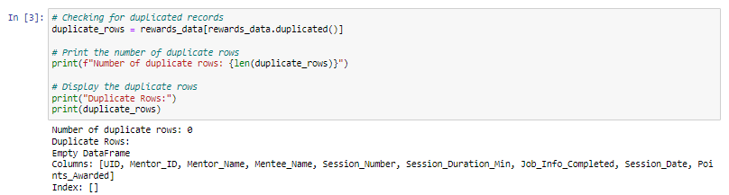

Figure 1:Duplicated Records

#### c. Handling Missing Values:

Next, the dataset was checked for any missing or incomplete data using the isnull() function. Missing values can significantly affect data analysis. A handful of columns were found to have records with missing values and were dropped, not taking into consideration the ‘Points Awarded’ column which was to be populated later on.

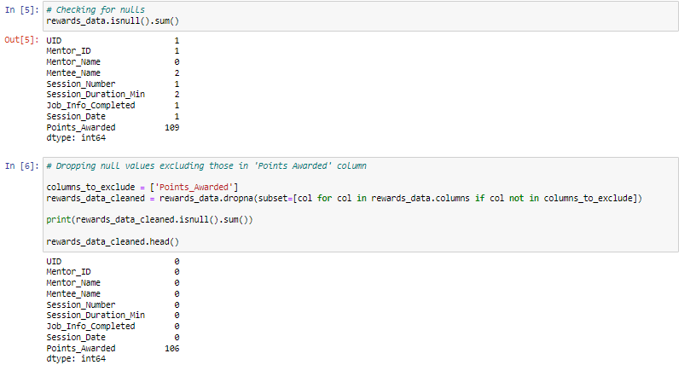

Figure 2:Missing Values

#### d. Dropping of Unnecessary Columns

After meticulously going through the dataset, I noted that the was unique identifier ‘UID’ and that of mentors’ ‘Mentor_ID’ were not unique at all throughout the dataset and decided to fully drop the columns. I further created new unique identifiers for each mentor, mentee as well as each recorded session.

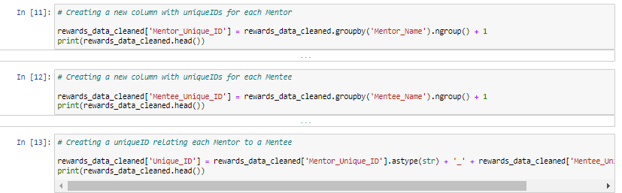

Figure 3:Unnecessary Columns

#### e. Data Type Correction:

Numeric columns like ‘Session_Duration’ and ‘Session_Duration_Min’ were appropriately assigned to their correct data type format (integer). ‘Session_Date’ was also re-assigned to datetime format.

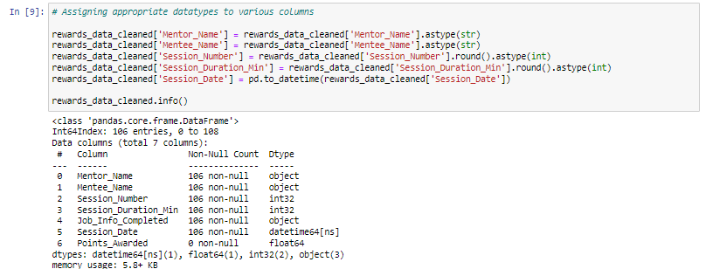

Figure 4:Datatype Correction

#### f. Verification and Quality Check:

After cleaning, the dataset was reviewed to ensure all operations were successfully applied. A quick summary of the dataset, including its shape and column details, was generated to verify the data quality and saved to a new Excel

### 2. Tools Used:

Python: The primary programming language used for this task.

Pandas: A Python library for data analysis and manipulation, used extensively for loading, cleaning, and inspecting the dataset.

Jupyter Notebook: An interactive environment for performing the data cleaning and documenting the process simultaneously.

### 3. Findings:

Duplicates: No duplicated records were found thus none removed.

Missing Values: A few entries were missing critical information, such as session dates or mentee name, and were excluded from the analysis.

Unnecessary Columns: The columns ‘UID’ and ‘Mentor_ID’ were of no use to the dataset and had to be dropped and new unique IDs recreated for the various columns.

Standardization: Reassignment of columns to their appropriate datatypes to ensure the integrity of the data in further analysis processes.

## Task 2: Legacy Point Allocation

### Rules for Point Allocation

The points allocation process is governed by three main rules:

Signup Points: Every mentor who participates in the program is awarded 250 points upon signing up.

Two Mentees Rule: Mentors who have mentored at least two different mentees are awarded an additional 1000 points.

Mentorship Points: Mentors receive 500 points for mentoring the same mentee for at least two sessions that meet the following criteria:

Each session must be at least 30 minutes long.

At least one of the sessions must have "Job Info Completed" marked as "Yes."

### Brief Report on Point Allocation Results

The point allocation system rewards mentors based on three key aspects: their initial signup, their involvement with multiple mentees, and the quality and quantity of their mentorship sessions.

Signup Points were uniformly awarded to all mentors, ensuring that every participant in the program starts with an equal base score.

Two Mentees Points were awarded to mentors who mentored at least two different mentees, incentivizing mentors to engage with more participants in the program. Mentors who focused on a single mentee did not receive these points, reinforcing the program's objective of broadening mentorship reach.

Mentorship Points rewarded mentors for conducting at least two sessions of significant duration (30 minutes or more) and providing job-related guidance ("Job Info Completed"). This highlights the program's focus on both quantity (multiple sessions) and quality (significant duration and job-related mentorship).

In total, mentors who demonstrated consistent engagement across multiple mentees and high-quality mentorship received the highest scores. This points allocation approach ensures that mentors are rewarded for broadening their impact and providing meaningful, job-related advice, aligning with the program's goals of enhancing professional development through mentorship.

### Step-by-Step Outline for Point Allocation Process

Data Preparation:

Import the dataset and ensure that all necessary columns (Mentor_Unique_ID, Mentee_Name, Session_Duration_Min, Job_Info_Completed, etc.) are properly formatted.

Clean the data by removing duplicates and handling any missing values.

Rule Implementation:

Assign 250 points to all mentors for signing up by adding a Signup_Points column.

Group by Mentor_Unique_ID and count the unique mentees. Award 1000 points to mentors who have mentored at least two different mentees by adding a Two_Mentees_Points column.

For each mentor-mentee pair, apply the session duration and job info criteria. If both conditions are met, award 500 points in the Mentorship_Points column.

Total Points Calculation:

Create a Total_Points column by summing the Signup_Points, Two_Mentees_Points, and Mentorship_Points.

Testing and Validation:

Unit Testing: For each rule, manually verify a few cases to ensure that the points are being awarded correctly (e.g., check if mentors with two mentees received 1000 points).

Edge Case Testing: Test scenarios with mentors who have exactly one mentee, or whose sessions are shorter than 30 minutes, to confirm no points are incorrectly awarded.

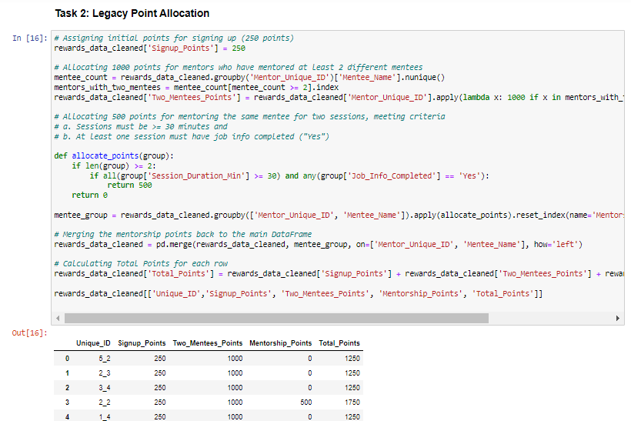

Figure 5:Legacy Point Allocation

## Task 3: Deriving Reward Dashboard and Insights

### 

Figure 6:Dashboard

### Actionable Recommendations

1. **Enhance the Speed of Reward Fulfillment to Improve User Satisfaction**

* **Objective**: Decrease the time it takes for users to receive rewards, particularly for new users and low engagement segments, where delays are associated with lower satisfaction.
* **Implementation**:

Streamline the reward fulfillment process, especially for digital rewards, which can be distributed instantly.

Partner with logistics providers to optimize delivery times for physical rewards in regions experiencing delays.

2. **Introduce Regionalized Reward Offerings to Meet Country-Specific Preferences**

* **Objective**: Cater to the geographic preferences observed in different regions, which can increase engagement by offering rewards that are more relevant to users in specific countries.
* **Implementation**:

Based on data, adjust reward offerings to include region-specific options. For example, in Country A, expand the selection of digital rewards, while in Country B, focus on physical goods or vouchers that align with user preferences.

Incorporate localized promotional campaigns to highlight rewards that resonate most with users in each country.

**3. Utilize Data Analytics to Personalize Reward Recommendations**

* **Objective**: Improve user engagement by providing personalized reward suggestions based on user behavior, preferences, and past activity.
* **Implementation**:

**Leverage user data**: Analyze user engagement patterns, session length, and reward redemption history to predict preferences and recommend personalized rewards. For example, if a mentor frequently redeems digital vouchers, prioritize showing them similar options.

**Dynamic reward catalog:** Tailor the reward catalog each user sees to highlight the most relevant rewards, based on their engagement level and geographic location. This personalization can increase the likelihood of redemption and satisfaction.

**Continuous feedback loop**: Collect feedback on user satisfaction with recommended rewards and adjust the algorithms accordingly to improve future personalization efforts.